Inrush current Analysis
Norbert Doerry
July 11, 2026
- Introduction
When initially energized, or during a change in operating mode, many loads may draw an inrush current from the power system that may be 10 times or more of their rated load current; this inrush current may last for between a few milliseconds and a few seconds (15 ms to 35 ms is typical). During the duration of the inrush current, a voltage sag may be experienced by other loads in the system. During normal operation, as long as the voltage sag stays within transient tolerance limits, and circuit protection doesn’t trip, these other loads should not be impacted by voltage sag. IEEE Std. 45.1 recommends a voltage transient tolerance of ±20% with a transient recovery time of 1.5 seconds. During initial energization of a dead bus, ensuring circuit protection does not trip is a main consideration; keeping the voltage sag within limits on already energized busses (if applicable) is also important. Selecting and configuring circuit protection to accommodate inrush current is not in the scope of this document; this document will focus on helping ensure the inrush current does not lead to the voltage dip exceeding the voltage transient tolerance.
Different types of sources are better able than others to maintain system voltage within power quality transient limits. Synchronous generators are able to supply a significant amount of inrush current, power electronic converters on the other hand are more limited in their ability to provide inrush current.
The greatest demands for inrush current are typically from large transformers, induction motors, solenoid valves, and equipment with large input filter capacitors. The most critical times for inrush current is when recovering from a dark ship or dead ship when many loads could potentially start at the same time; and when a de-energized switchboard is energized from another already powered switchboard. The concept of operation for recovering from a dark ship or dead ship should be well defined to understand which loads will be energized at the same time. The starting of large loads and power conversion equipment should be examined to ensure voltage transient tolerance limits are not exceeded.
Inrush current is difficult to model in a time-based simulation; the dynamics are largely non-linear and the initial conditions are not likely to be near the final steady-state equilibrium. For electromagnetic equipment, lumped parameter models offer only a rough approximation of what is happening; finite-element analysis may provide better solutions, but requires details on equipment design that are often not available. Instead, inrush current analysis is usually performed in an approximate matter; inrush current reduction or mitigation techniques are applied to the equipment with the highest anticipated inrush current.
The inrush current properties of each load should be described in the appropriate entry in the load list.
While this document includes a number of examples of circuits implementing controllers, many modern systems rely upon programable logic controllers (PLCs) that implement much of the logic digitally. The schematics are useful in demonstrating the intended operation. There is no guarantee that the schematics presented are appropriate for any particular application.
- Inrush current types
  - Resistive loads
Many resistive loads do not have a large inrush. Because resistance usually increases with temperature, the initial current, when the resistance is lower, may be somewhat larger than when the load warms up and the resistance increases. For loads where the temperature difference is not large, the difference in load is usually not significant. On the other hand, for resistive loads where the change in temperature is large, such as heaters and tungsten filament lamps, the inrush current can be substantial until the resistive element heats up to its operating temperature. Small light bulbs may have an inrush current up to 14 times its rated current for several milliseconds. The inrush for tungsten filament lamps of 500 watts or more can last for several seconds. Large resistive heaters with considerable thermal inertia may take tens of seconds to fully heat up.
Small resistive loads may employ a negative temperature coefficient (NTC) device in series with the main resistive element; the resistance of the NTC devices decrease as temperature increases. With a higher cold resistance, the inrush current is limited. In some cases, a contactor shorts out the NTC device after a specified time or when the main resistive element achieves a given temperature.
Positive temperature coefficient (PTC) devices with a low thermal inertia may also be used in series with resistive loads. At below rated current, the PTC device has a low resistance. When inrush current is applied to the PTC device, its resistance rapidly increases to limit the peak inrush current. After the inrush current decays away, the PTC device cools and its resistance decreases. In some cases, a contactor shorts out the PTC after a specified time or when the main resistive element achieves a given temperature. How fast the PTC trips to its high resistance state is one of the key parameters for determining if this method will be successful; the normal range is from tens to hundreds of milliseconds which may be too slow.
Another strategy is to employ a high resistance startup heater to warm the main resistive element before applying power to the main resistive element. Upon being energized, the startup heater is powered until the main resistive element achieves a specified temperature; at that time, power to the startup heater is turned off and the main resistive element is energized.
Still another strategy is for the main resistive element to be powered by a power electronic converter that regulates the current into the main resistive element. This technique can virtually eliminate the inrush current.
One can also explore using technologies that don’t require heating conductors with a positive temperature coefficient; Light emitting diodes (LEDs) for example, may be employed to replace filament lamps.
  - Motors
Most motors on ships are induction motors that are directly connected to the power system when started (across the line start or alternately direct-on-line). These motors can have a significant inrush current as they start. The inrush current can last for a second or more. For a normal motor, the Locked Rotor Amps (LRA) listed on the motor nameplate may be used as an estimate of the inrush current magnitude. If the LRA is not known, estimating the inrush current as 5 to 10 times the full load amps is reasonable. If multiple motors automatically restart when power is restored during recovery from a dark ship or dead ship, then the sum of the inrush currents of the various motors may result in the voltage dropping below the transient voltage limits.
Many motors will list on their nameplate a locked-rotor indicating code letter. The National Electric Code provides a range of KVA per Horsepower with Locked Rotor for each code letter as shown in Table I. For inrush current applications, use the higher range limit for the code letter. For the rated horsepower of the motor, determine the inrush kVA. For single phase motors, divide the inrush kVA by the nominal system voltage to obtain the LRA. For three phase motors, divide the inrush kVA by the nominal system voltage and the square root of three to obtain the LRA. The ratio of the LRA to the rated current is approximated by multiplying the higher end kVA per HP by 0.7457 and dividing by the power factor and efficiency at full load; multiplying the higher end kVA per HP by 1.1 gives a rough estimate.
Table I: Locked Rotor KVA per Horsepower for Code Letter (NEC section 470)
Code Letter | Kilovolt-Ampere per Horsepower with Locked Rotor
A | 0-3.14
B | 3.15-3.54
C | 3.55-3.99
D | 4.0-4.49
E | 4.5-4.99
F | 5.0-5.59
G | 5.6-6.29
H | 6.3-7.09
J | 7.1-7.99
K | 8.0-8.99
L | 9.0-9.99
M | 10-11.19
N | 11.2-12.49
P | 12.5-13.99
R | 14.0-15.99
S | 16.0-17.99
T | 18.0-19.99
U | 20.0-22.39
V | 22.4 and up
One horsepower is 0.7457 kW mechanical.
A motor controller that implements automatically restarting when power is restored is called a Low Voltage Release (LVR) controller. The simplest LVR controller is a multi-pole switch that turns the power on and off to the motor. Figure 1 depicts a more advanced LVR controller which may be controlled locally, or if placed in remote control, may be controlled remotely (possibly via a machinery control system). The machinery control system may be configured to turn off the load before power is restored; the load is turned back on seconds later after the initial transients. An alternate approach is shown in Figure 2; a time delay relay does not allow the contactor / relay to close until a short time after power is restored. The time delay is either fixed or adjustable; time delays between 0.1 seconds and 10 minutes are possible.
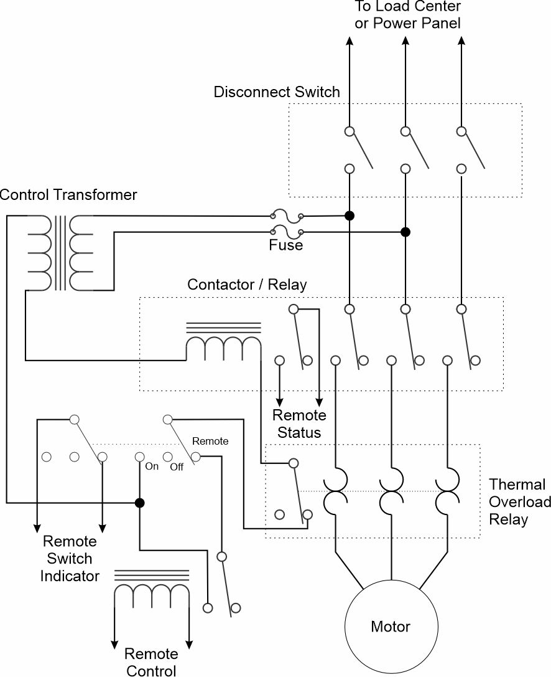
Figure 1: Low voltage release with local and remote control.

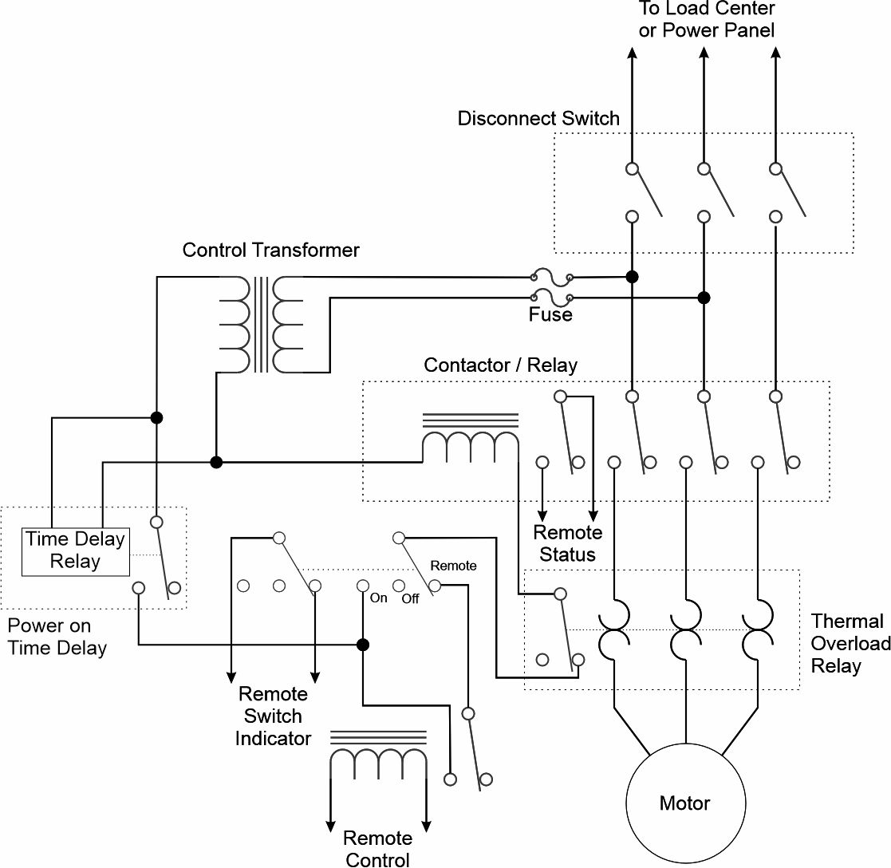
Figure 2: Low voltage release with local and remote control and power on time delay.
If a variable speed drive (VSD) is used to power a motor, the inrush current for starting the motor is typically limited to no more than 1.5 times the rated current. The VSD controls the current into the motor to avoid the inrush current. The inrush current for powering up the VSD is typically small because the internal capacitance is usually charged relatively slowly; usually the VSD power up inrush current is less than full load current of the motor. A VSD enables the control system to automatically start the motor when power is restored following a dark ship or dead ship start; the starting of loads can be timed to avoid multiple inrush currents at the same time.
Other types of motor controllers may also reduce the inrush current. Some, for example, insert a set of starting resistors or starting inductors in series with the motor upon start up. Once the motor speed has reached a minimum value (or a specific time delay has elapsed), a contactor either switches out or shorts out the starting resistors / inductors to apply full voltage across the motor. Figure 3 depicts an example of a low voltage release motor controller with starting resistors.
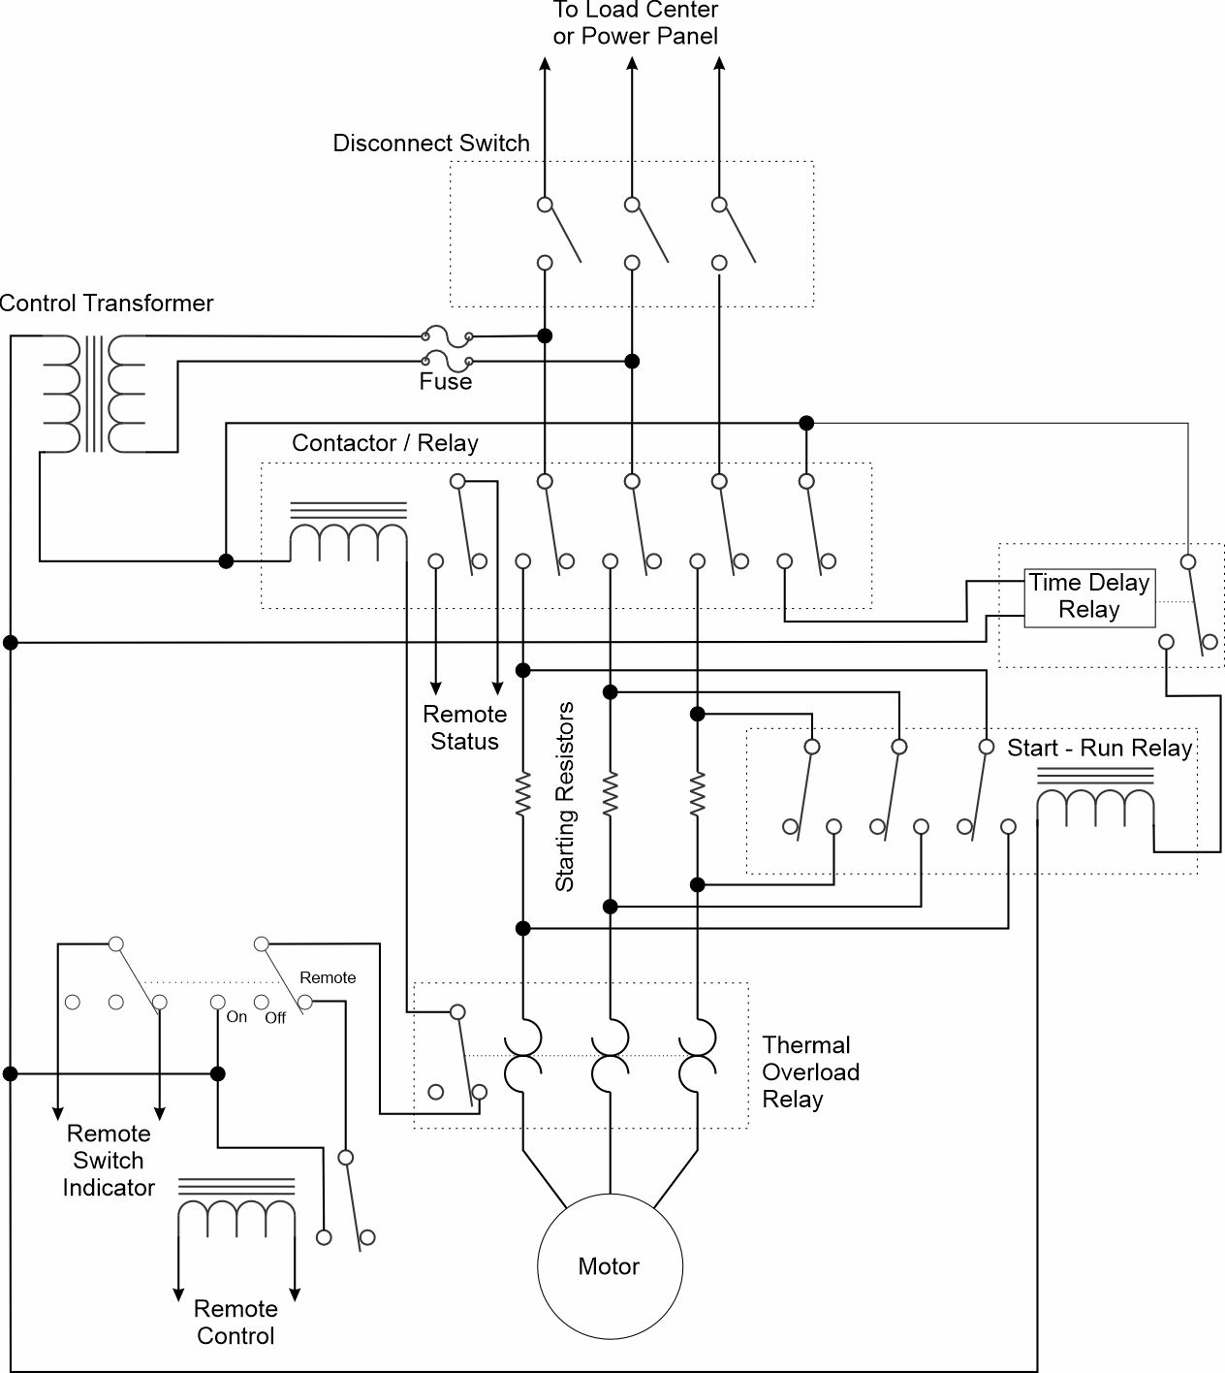
Figure 3: Low Voltage Release motor controller with starting resistors
Another technique for three phase motors is to initially connect the motors windings in wye; thereby reducing the voltage on each of the windings. When the motor speed has reached a minimum value (or a specific time delay has elapsed), a contactor reconnects the motor windings in delta.
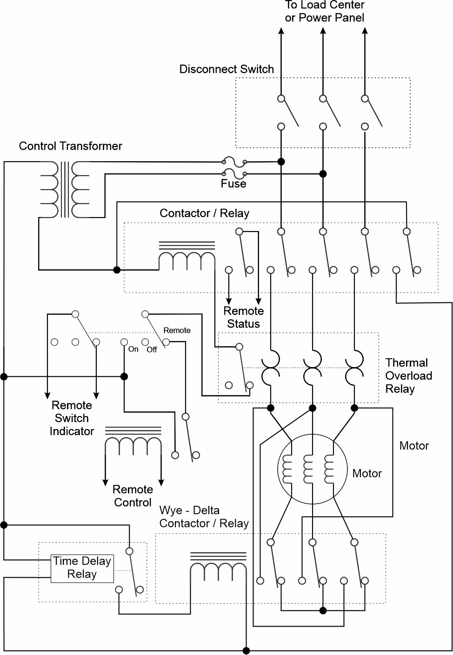
Figure 4: Low Voltage Release motor controller with wye-delta starting
Induction motors that are not emergency loads, or may prove hazardous if automatically re-energized, are often provided with a Low Voltage Protection (LVP) controller. As depicted in Figure 5, These controllers are usually identified by having separate start and stop buttons. When the start button is pressed, power is provided to a contactor / relay with contacts that connect across the start button, and contacts powering the motor. The contacts across the start button enable the motor to continue running when the start button is released. The stop button interrupts power to the relay; the motor will stop and will not restart when the stop button is released. Furthermore, if the voltage drops below the hold voltage of the relay, the relay will open and interrupt power to the motor; the motor won’t start again until power is restored and the start button is pressed. This prevents the motor from automatically starting and drawing its inrush current when power is restored following a dark ship or dead ship condition. Figure 5 also depicts a thermal overload that will open the contacts to the motor as well as “turning off” the relay when the motor draws too much current for too long. Additional connections are provided to enable remote sensing of whether the motor is on or off, as well as enabling remote starting and stopping of the motor.
Remote starting enables the control system to automatically start the motor when power is restored following a dark ship or dead ship start; the starting of loads can be timed to avoid multiple inrush currents at the same time. Low voltage protection motor controllers are also compatible with inrush current limiting techniques such as the use of starting resistors and with the use of wye-delta starting.
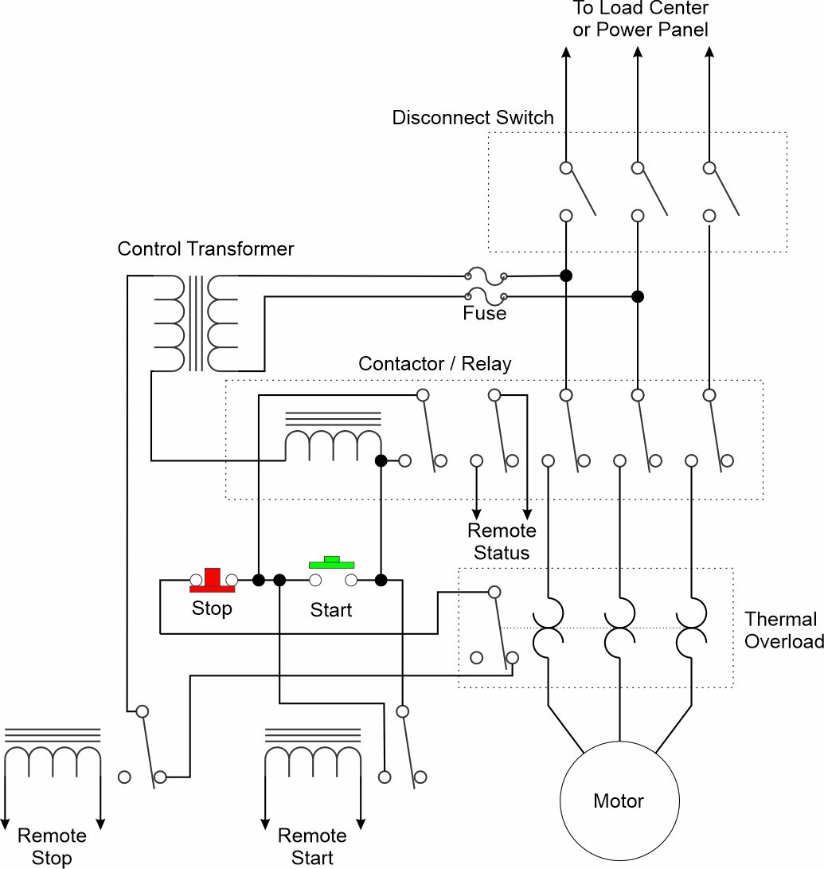
Figure 5: Low Voltage Protection Motor Controller
  - Transformers
When a transformer is initially energized at a zero crossing of the voltage, the flux within the core can achieve twice its steady-state value. Since most transformers are not designed to handle twice the steady-state flux, the transformer is likely to become saturated, requiring high current levels (inrush current) to produce the required flux. The peak inrush current may be approximated by dividing the peak voltage by the primary winding resistance. Another technique is to multiply the full load current by a multiplier provided in a datasheet. This multiplier is typically between 5 and 12.
One method for minimizing the transformer inrush current is to connect the transformer to the voltage source when the voltage source is near its positive or negative peak values. Other ways include the use of series starting resistors, soft starters that control the current to keep it below the full rated current, and pre-magnetization circuits that establish the magnetic flux within the transformer.
A pre-magnetization circuit is often used with medium voltage to low voltage transformers in marine applications. This circuit injects a sinusoidal current into the secondary of the transformer so that the magnetization of the core is synchronized with the medium voltage source. Once synchronization has been achieved, the breaker to the medium voltage source is closed and the pre-magnetization circuit is disconnected. A pre-magnetization circuit can virtually eliminate the inrush current.
Within most marine applications, inrush current mitigation is almost always required for medium voltage to low voltage transformers. These transformers usually have a rated power that is usually a significant fraction of the full load rating of the smallest generator set; in some cases, the transformer may have a power rating greater than the rating of the smallest generator set. The generator set is not likely able to provide 5 to 12 times the full rated current of the transformer while maintaining power quality requirements; the bus voltage transient will likely exceed 20% of the nominal system voltage.
  - Equipment with capacitive filters
Electronic equipment often have a rectifier stage followed by dc filter capacitor. In older designs, the rectifier would be a passive rectifier with the filter capacitor directly connected to its output. The inrush current into a discharged capacitor may only be limited by the internal resistance of the capacitor. These passive rectifiers may also introduce significant harmonic current into the power system. Inductors on the input to the rectifier stage are often used to suppress the harmonic currents. The impedance of these inductors add to the internal resistance of the capacitor to reduce the magnitude of the inrush current. In more modern designs, active rectification is used which both reduces the harmonic currents, and reduces the inrush current by slowly “soft” charging the dc capacitor at startup.
Equipment data sheets or the manufacturer should be consulted to determine the inrush current demand of large (connected load greater than 2% of the rating of the smallest generator set) electronic equipment.
- Impact of inrush current on sources, switchboards, load centers, and power panels
Sources in general cannot react immediately to inrush current to regulate the voltage. Consequently, if loads automatically start upon energization of a dead bus, their inrush current should be minimized as much as practical. Non-emergency loads with a large inrush current should be powered via a Low Voltage Protection controller. Other loads with a large inrush current should employ time delays upon energization to spread out in time the application of inrush current to the sources.
  - Generators
The reaction time of a voltage regulator on a synchronous generator to a disturbance is limited by the open-circuit transient time constant which measures how quickly the field current can react to a change in excitation. A typical generator will have an open-circuit transient time constant on the order of seconds; much slower than most inrush currents. This means the voltage regulator will not be able to regulate the terminal voltage in response to the inrush current. Instead, the step increase in current multiplied by the sub-transient reactance should provide a rough estimate of the voltage drop that will be experienced at the generator terminals. Since limiting the transient voltage drop to 20% of the nominal system voltage is typically specified by power quality, the largest Per Unit (PU) inrush current (step current increase) that can be tolerated would be 0.20 divided by the sub-transient reactance (PU). For many synchronous generators in the megawatt range, the resulting PU inrush current limit is on the order of 1.4 to 2.5. This inrush current limit is significantly lower than the available fault current; the available fault current is based on the output of the generator being short-circuited.
For a load that has a connected load less than 5% of the rating of the lowest rated generator set, its inrush current on power-up is likely to not exceed 0.5 PU (based on the generator rating). Since the generator set can maintain the voltage within transient tolerances of up to 1.4 PU or so, the random starting of the load will not likely lead to a service disruption. Larger loads should limit their inrush current to less than 0.5 PU so that random starting of the load does not result in a service disruption.
  - Transformers
The voltage on the secondary of a transformer when exposed to the inrush current of its loads is a function of the load inrush current, the impedance of the transformer, and the voltage dip of the power system supplying the transformer primary in response to the inrush current. The impedance of a transformer can be on the order of 0.05 PU. This impedance however, is calculated at 60 Hz. The transient voltage typically has a higher frequency and the impedance at that frequency should be used. If the transient voltage frequency is not known, assuming a frequency of 1 kHz may be appropriate. If we assume the voltage at the primary side of the transformer is not influenced by the inrush current, the impedance of the transformer is largely inductive, and the voltage transient has a frequency of 1 kHz, then the maximum inrush current that should not cause the transient voltage to deviate more than 20% is 0.20 divided by the PU impedance (corrected for the voltage transient frequency) or on the order of 0.24 PU. In reality, the allowable inrush current will be less because the inrush current will also impact the voltage on the primary. If the transformer power rating is about the same as the generator supplying it, the allowable inrush current may only be on the order of 0.2 PU (based on transformer ratings). For this reason, controlling inrush current of loads powered by transformers is important to ensuring voltage transient tolerance limits are achieved.
  - Power electronics
The amount of inrush current that a power electronic converter can supply is a function of the thermal limits of the semiconductors, and the amount of energy stored in its dc link capacitor. A typical converter may supply on the order of 1 PU inrush current (in addition to 1 PU of steady state current) for a maximum of 3 seconds. If the maximum amount of inrush current or the time duration is exceeded, the converter often will self-protect and shut down; a dark ship may result. Manufacturer’s datasheets should be consulted to determine the inrush current supplying capability of the power electronic converter.
  - Switchboards, load centers and power panels
The primary impact of inrush currents on load centers and power panels is the voltage drop in the feeder cables to the load centers and power panels. Normally the impedance of the bus-ties and generator feeder cables are smaller in comparison to the impedance of the load center and power panel feeder cables; unless one knows that this is not the case, the impedances of the bus ties and generator feeder cables may usually be ignored. Through circuit analysis, one can determine the maximum inrush current that may be supplied at the switchboard, load center or power panel and still not exceed the voltage transient tolerance requirement.
- Inrush current analysis
  - Load List
One of the first tasks is understanding the inrush current requirement of the loads on the load list. Every load with a rated power over about 2% of the rated power of the smallest generator set should be examined to determine the amount of inrush current it could potentially draw as well as whether it is provided with LVP functionality. The duration of the inrush current should be estimated, along with any time delays built into the controller logic. Smaller loads known to have high inrush current should also be examined to characterize the inrush current and LVP functionality.
Where available, employ measured data to estimate the inrush current requirement.
Additionally, the inrush current requirements of power electronic converters and transformers that are part of the power system should be characterized.
  - Feeder cable impedance estimation
The inductance and resistance of the feeder cables should be estimated based on manufacture’s datasheets, standards, handbooks, measurements, or approximation based on cable dimensions. See Doerry (2025) for example inductances and resistances for LSTSGU cable as well as methods for calculating cable inductance. For inrush current calculations, one should account for the inrush current having higher frequency components; if the transient voltage frequency is not known, the cable impedance at that frequency should be used; otherwise, the cable impedance at 1 kHz may be appropriate.
For loads where a mode change results in a large inrush current, one may wish to ensure that the voltage transient at the load terminals (rather than at the load center or power panel) do not exceed the power quality requirements. For these loads, the impedance of the load feeder cable should be estimated.
  - Switchboard, Load Center, and Power Panel Capability
Using the properties of the sources, power electronic conversion equipment, transformers, and feeder cables to load centers and power panels, the maximum inrush current that may be supported by the switchboards, load centers, and power panels should be calculated based on section 3.
  - Scenario Development
Various scenarios should be developed to identify the worst-case transient voltages caused by inrush current. These scenarios should be based on the electrical power system concept of operations (EPS-CONOPS). The scenario should include an initial state describing which sources, power conversion equipment and loads are initially online, the configuration of bus-tie breakers, and which loads are simultaneously powered on to cause the inrush current. Scenarios should include energizing power panels, load centers, and switchboards that are initially deenergized. Other scenarios should examine loads that have a large inrush current but their inrush current occurs as part of a “random” load mode change, or from starting using an LVP controller. Still other scenarios should examine the initial powering of large transformers and power electronic equipment.
  - Calculating total inrush current
For each scenario, calculate the inrush current as a function of time for each switchboard, load center and power panel by summing the inrush current profiles of all the scenario applicable loads connected to the switchboard, load center, and power panel.
  - Identifying inrush current issues
If under any scenario, the total inrush current calculated for any switchboard, load center or power panel exceeds its capability, then an inrush current issue exists. The details of the particular scenario should be examined to identify which loads are the most significant contributor to the issue and candidates for inrush current mitigation.
- Inrush current mitigation
If the results of the inrush current analysis show a potential issue with providing inrush current, means to reduce the inrush current demand or means to improve the sourcing of in rush current should be explored. Possible technologies include:
- Install soft starters or variable speed drives on induction motors.
- Install a pre-magnetization system for initializing the magnetic field on large transformers.
- Install starting resistors or current limiters on equipment with large inrush currents.
- Use wye-delta starting on motors.
- Incorporate energy storage to provide the inrush current.
- Increase the rating of power electronic converters so they can provide more inrush current.
- Employ control systems, time delay relays, interlocks, or Low Voltage Protection (LVP) controllers to prevent multiple loads with high inrush current from starting at the same time.
- Replace loads with functional equivalents that have a lower inrush current.
- References
IEEE Std 45.1 IEEE Recommended Practice for Electrical Installations on Shipboard—Design
NFPA 70, National Electrical Code (NEC), https://www.nfpa.org/codes-and-standards/nfpa-70-standard-development/70.
Doerry, Norbert, "Voltage Drop Calculations on Shipboard Power Systems", presented at 16th International Symposium on Practical Design of Ships and Other Floating Structures PRADS 2025, Ann Arbor, MI, USA, October 19th - 23rd 2025.

